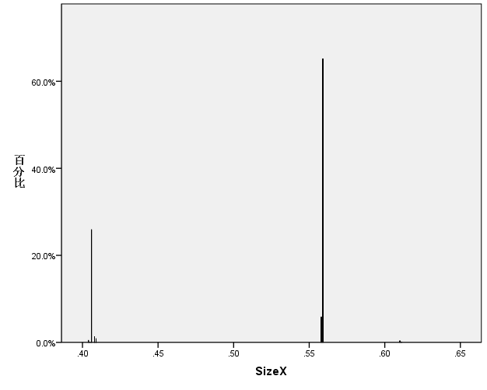

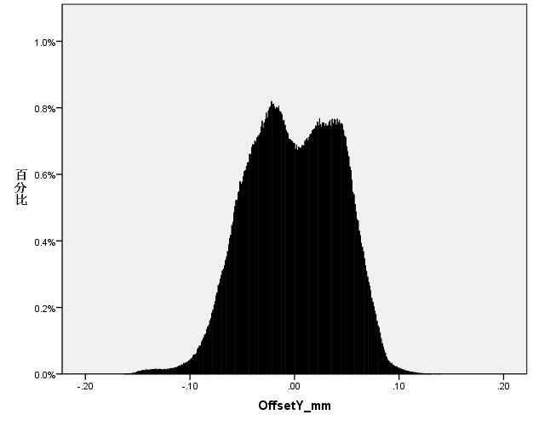

|  |  |  |  |  |  |
| --- | --- | --- | --- | --- | --- |
| **bga描述统计** | | | | | |
|  | 数字 | 最小值(M) | 最大值(X) | 平均值(E) | 标准偏差 |
| SizeX | 1851024 | .40 | .61 | .5156 | .06922 |
| SizeY | 1851024 | .40 | .61 | .5157 | .06897 |
| Volume_Per | 1851024 | 50.17 | 188.91 | 112.2812 | 8.53160 |
| Volume_um3 | 1851024 | 14.65 | 60.14 | 32.5368 | 6.18982 |
| Area_Per | 1851024 | 46.10 | 146.16 | 101.1627 | 5.34957 |
| Area_um2 | 1851024 | 11.25 | 38.46 | 22.4903 | 3.86572 |
| Height_um | 1851024 | 111.04 | 209.47 | 144.3656 | 9.01801 |
| OffsetX_mm | 1851024 | -.14 | .15 | .0012 | .03461 |
| OffsetY_mm | 1851024 | -.16 | .14 | -.0009 | .04326 |
| 有效 N（成列） | 1851024 |  |  |  |  |

|  |  |  |  |  |  |  |  |  |  |  |  |  |  |  |  |  |
| --- | --- | --- | --- | --- | --- | --- | --- | --- | --- | --- | --- | --- | --- | --- | --- | --- |
| 数据集 | WMIFS | | MRMR | | CIFE | | CMIM | | DISR | | JMI | | MIFS | | MIM | |
| 特征数 | 准确率 | 特征数 | 准确率 | 特征数 | 准确率 | 特征数 | 正确率 | 特征数 | 准确率 | 特征数 | 准确率 | 特征数 | 准确率 | 特征数 | 准确率 |
| SOne | 3 | 93.92 | 7 | 89.80 | 8 | 89.15 | 9 | 88.16 | 8 | 88.49 | 8 | 88.49 | 6 | 89.31 | 7 | 88.49 |
| STwo | 9 | 82.32 | 9 | 82.32 | 9 | 82.32 | 9 | 82.32 | 9 | 82.32 | 9 | 82.32 | 9 | 82.32 | 9 | 82.32 |
| Qfp | 1 | 82.32 | 1 | 82.32 | 1 | 82.32 | 1 | 82.32 | 1 | 82.32 | 1 | 82.32 | 1 | 82.32 | 1 | 82.32 |
| Chip | 7 | 77.03 | 8 | 76.89 | 8 | 76.89 | 9 | 76.82 | 9 | 76.82 | 9 | 76.82 | 8 | 76.89 | 9 | 76.82 |
| Other | 7 | 74.33 | 9 | 73.83 | 9 | 73.83 | 8 | 76.33 | 8 | 76.33 | 8 | 76.33 | 9 | 73.83 | 8 | 76.33 |
| Mlf | 9 | 61.78 | 8 | 61.86 | 9 | 61.78 | 6 | 62.74 | 4 | 65.12 | 8 | 62.34 | 8 | 61.86 | 7 | 64.48 |
| Bag | 4 | 98.80 | 8 | 98.48 | 9 | 98.38 | 9 | 98.40 | 7 | 98.50 | 7 | 98.50 | 8 | 98.50 | 7 | 98.50 |
| 平均值 | **5.71** | 81.50 | 7.14 | 80.79 | 7.57 | 80.67 | 7.29 | 81.01 | 6.57 | 81.41 | 7.14 | 81.01 | 7 | 80.72 | 6.86 | 81.32 |

|  |  |  |  |  |  |  |  |  |  |
| --- | --- | --- | --- | --- | --- | --- | --- | --- | --- |
| **项间相关性矩阵** | | | | | | | | | |
|  | SizeX | SizeY | Volume_Per | Volume_um3 | Area_Per | Area_um2 | Height_um | OffsetX_mm | OffsetY_mm |
| SizeX | 1.000 | 1.000 | .225 | .928 | .011 | .950 | .277 | .127 | .070 |
| SizeY | 1.000 | 1.000 | .225 | .928 | .010 | .950 | .277 | .126 | .070 |
| Volume_Per | .225 | .225 | 1.000 | .563 | .581 | .378 | .707 | -.074 | .104 |
| Volume_um3 | .928 | .928 | .563 | 1.000 | .226 | .947 | .497 | .077 | .097 |
| Area_Per | .011 | .010 | .581 | .226 | 1.000 | .315 | -.163 | -.018 | .058 |
| Area_um2 | .950 | .950 | .378 | .947 | .315 | 1.000 | .197 | .117 | .086 |
| Height_um | .277 | .277 | .707 | .497 | -.163 | .197 | 1.000 | -.073 | .076 |
| OffsetX_mm | .127 | .126 | -.074 | .077 | -.018 | .117 | -.073 | 1.000 | .275 |
| OffsetY_mm | .070 | .070 | .104 | .097 | .058 | .086 | .076 | .275 | 1.000 |

Adaboost

根据结果更新模型

模型生成

生成

检测结果

GAN

检测模型

生成数据

数据源

判断现场数据

更新

生产数据

本地数据

WMIFS

特征选择

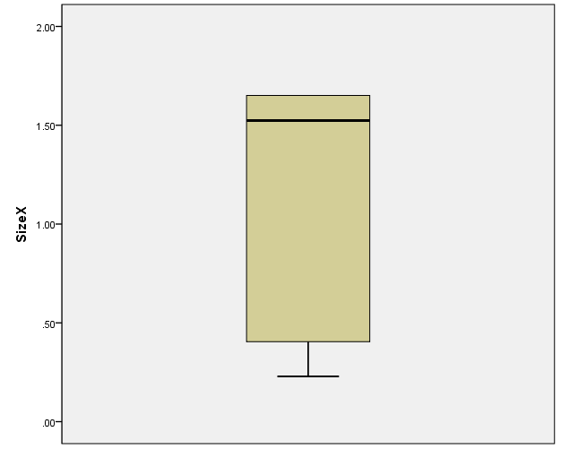

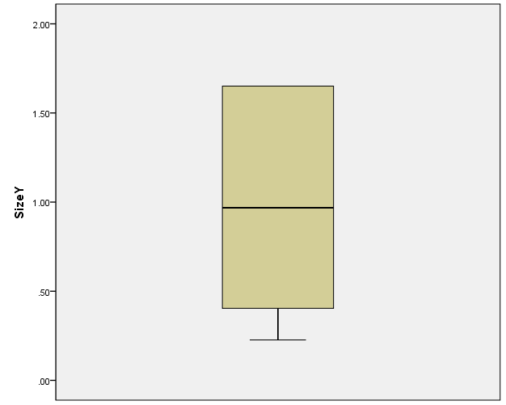

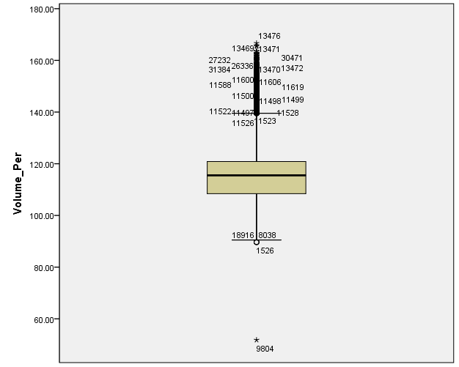 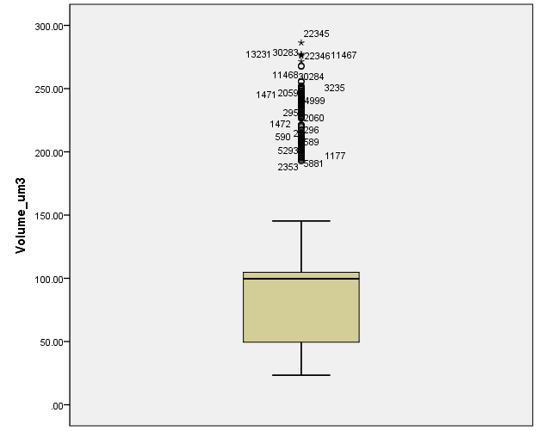

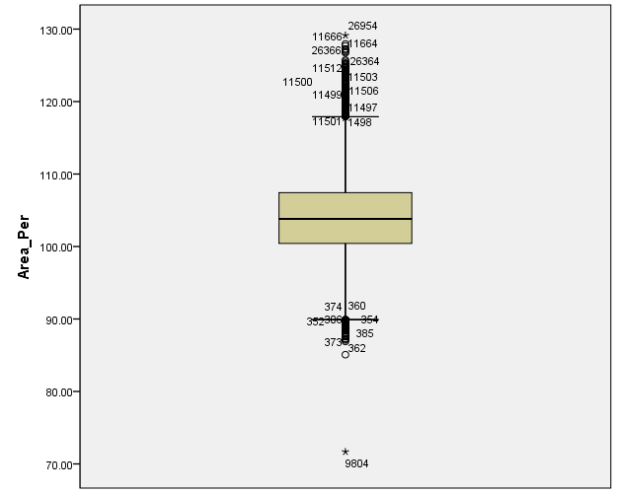

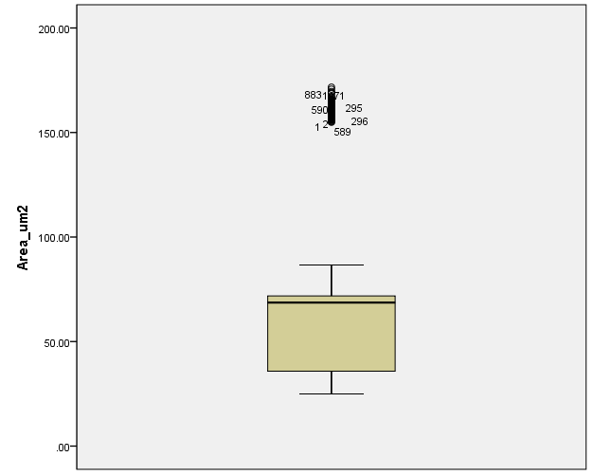

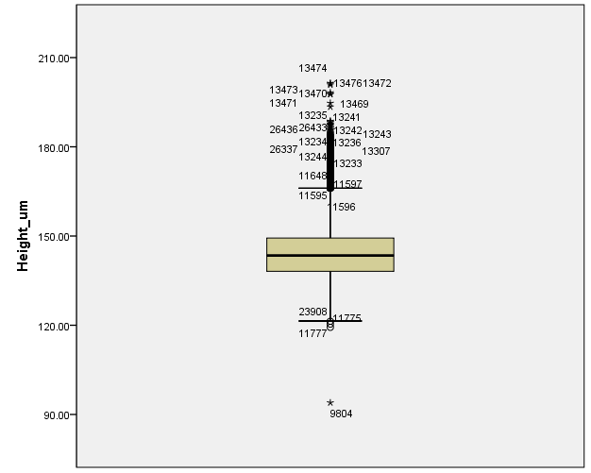

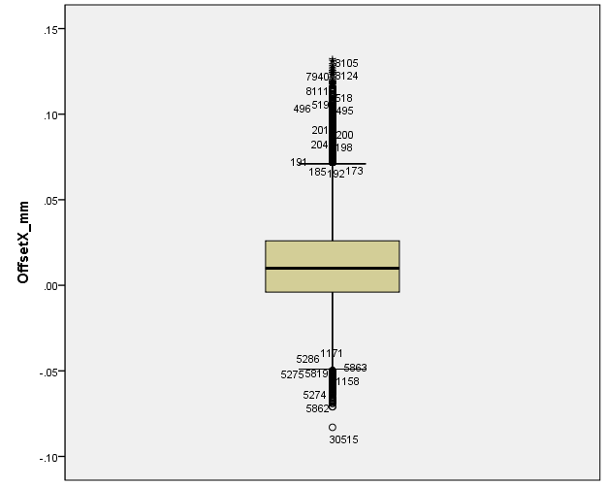

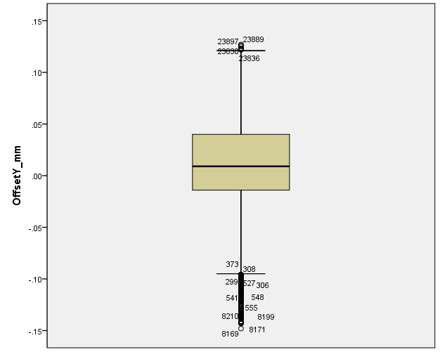

否

开始

结束

反馈异常

是

是否异常

更新模型

训练数据

检测结果数据

实时数据

训练模型

数据类型

GAN生成数据

特征选择

数据预处理